**Opening Meterpreter/getting a session:**

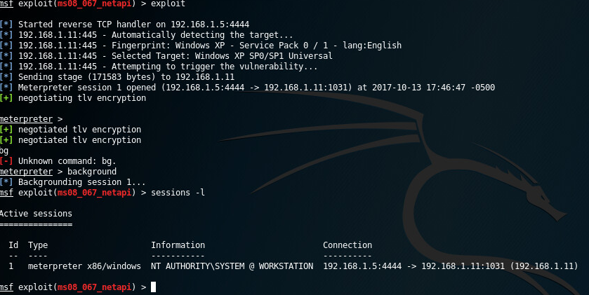

**Sysinfo:**

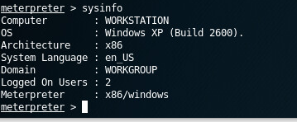

**Process List:**

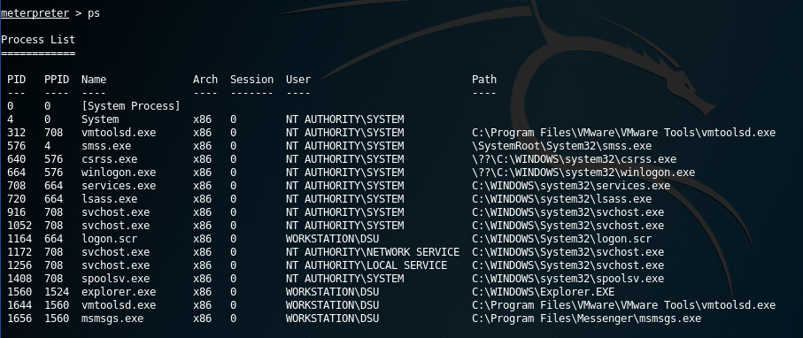

**Getting Process ID**

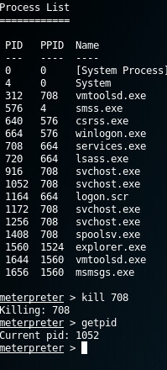

**Killing a process:**

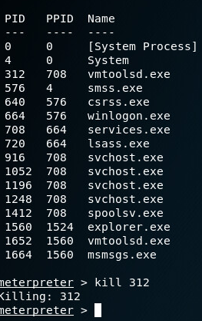

**Migrating:**

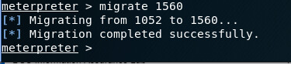

**Current Process Username:**

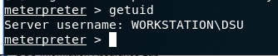

**Get System:**



**Keystroke Logging:**

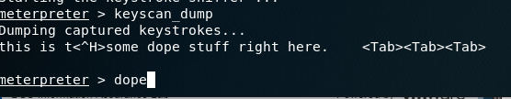

**UI Control:**

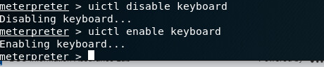

**Password Hashes:**

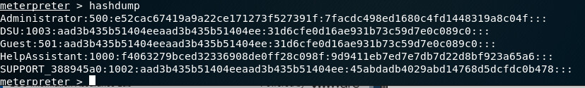

**Enumerate Desktops:**

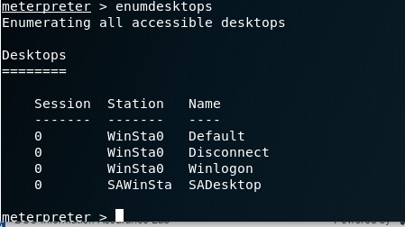

**Currently Active Desktop:**

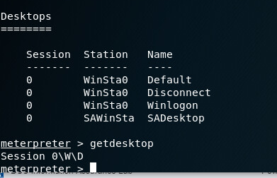

**Idle Time:**

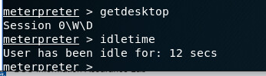

**Meterpreter Scripts:**

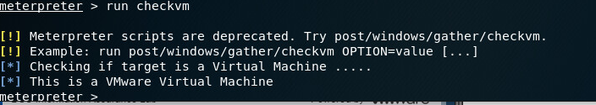

**Command Shell:**

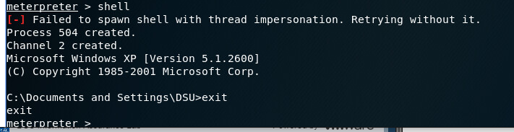

**Clearing Logs:**

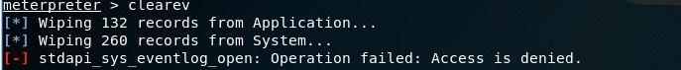

**Execute File:**

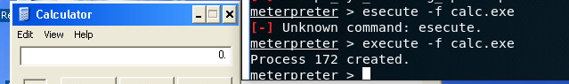

**Webcams:**



**Search:**

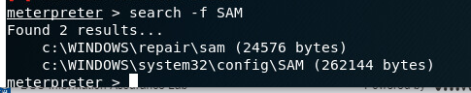

**Local Directory Traversal:**



**Downloading and Uploading Files:**

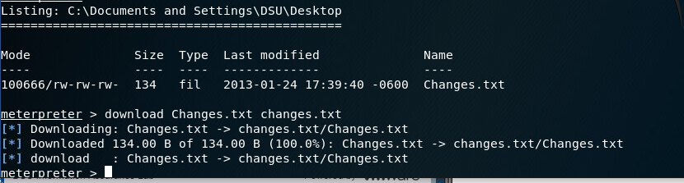

**Editing the Registry:**

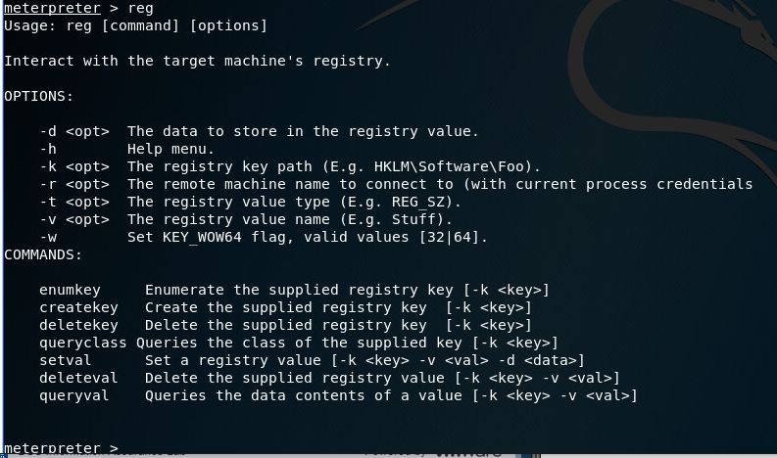

**Backgrounding Meterpreter:**



**Reboot and Shutdown:**

